PROJECT FILE
ON
Advanced Number to Word Converter



SUBMITTED BY: - DIPJYOTI BISHARAD

COURSE- ADVANCE DIPLOMA IN MULTILINGUAL COMPUTER TRAINING

COURSE CODE- ADMCT
TABLE OF CONTENTS

- Introduction

- Coding

- Outputs/Screenshots
INTRODUCTION

This program is a simple yet powerful GUI that can convert any number upto 19 digits (till the range of long) to its corresponding word.

The user has to enter an integer (negative or positive) in the text field. On clicking the ‘Convert’ button, the number will be displayed in words. On clicking ‘C’ button the screen will be cleared.

CODING

//**********************************************************
// PROJECT – Number to Word Converter
//**********************************************************

import java.awt.Container;
import java.awt.Cursor;
import java.awt.EventQueue;
import java.awt.event.ActionEvent;
import java.awt.event.ActionListener;
import java.util.logging.Level;
import java.util.logging.Logger;
import javax.swing.GroupLayout;
import javax.swing.GroupLayout.Alignment;
import javax.swing.GroupLayout.ParallelGroup;
import javax.swing.GroupLayout.SequentialGroup;
import javax.swing.JButton;
import javax.swing.JFrame;
import javax.swing.JLabel;
import javax.swing.JTextField;
import javax.swing.LayoutStyle.ComponentPlacement;
import javax.swing.UIManager;
import javax.swing.UIManager.LookAndFeelInfo;
import javax.swing.UnsupportedLookAndFeelException;
import javax.swing.LayoutStyle;

public class word extends JFrame
{
private JButton cls;
private JTextField input;
private JButton jButton1;
private JLabel jLabel1;
private JLabel result1;
private JLabel result2;
private JLabel result3;

public word()
{
initComponents();
setResizable(false);
setTitle("Number to Word converter - By Dipjyoti Bisharad");
this.jButton1.setToolTipText("Convert into Words");
this.cls.setToolTipText("Clear");
this.input.requestFocus();
}

private void initComponents()
{
this.input = new JTextField();
this.jLabel1 = new JLabel();
this.jButton1 = new JButton();
this.cls = new JButton();
this.result1 = new JLabel();
this.result2 = new JLabel();
this.result3 = new JLabel();
setDefaultCloseOperation(3);
setLocationByPlatform(true);

this.jLabel1.setText("Enter an Integer");

this.jButton1.setText("Convert");
this.jButton1.setCursor(new Cursor(12));
this.jButton1.addActionListener(new ActionListener()
{
public void actionPerformed(ActionEvent evt)
{
word.this.jButton1ActionPerformed(evt);
}
});
this.cls.setText("C");
this.cls.setCursor(new Cursor(12));
this.cls.addActionListener(new ActionListener()
{
public void actionPerformed(ActionEvent evt)
{
word.this.clsActionPerformed(evt);
}
});
GroupLayout layout = new GroupLayout(getContentPane());
getContentPane().setLayout(layout);
layout.setHorizontalGroup(layout.createParallelGroup(GroupLayout.Alignment.LEADING)
.addGroup(layout.createSequentialGroup()
.addGap(25, 25, 25).addComponent(this.jLabel1)
.addGap(26, 26, 26)
.addGroup(layout.createParallelGroup(GroupLayout.Alignment.LEADING, false)
.addGroup(layout.createSequentialGroup()
.addComponent(this.input, -2, 151, -2)
.addGap(18, 18, 18)
.addComponent(this.jButton1)
.addPreferredGap(LayoutStyle.ComponentPlacement.RELATED)
.addComponent(this.cls))
.addComponent(this.result1, -1, 488, 32767)
.addComponent(this.result2, -1, -1, 32767)
.addComponent(this.result3, -1, -1, 32767))
.addContainerGap(-1, 32767)));
layout.setVerticalGroup(layout.createParallelGroup(GroupLayout.Alignment.LEADING)
.addGroup(layout.createSequentialGroup()
.addGap(18, 18, 18)
.addGroup(layout.createParallelGroup(GroupLayout.Alignment.BASELINE)
.addComponent(this.input, -2, -1, -2)
.addComponent(this.jLabel1)
.addComponent(this.jButton1)
.addComponent(this.cls))
.addGap(18, 18, 18)
.addComponent(this.result1, -2, 13, -2)
.addPreferredGap(LayoutStyle.ComponentPlacement.RELATED)
.addComponent(this.result2, -2, 13, -2)
.addPreferredGap(LayoutStyle.ComponentPlacement.RELATED)
.addComponent(this.result3, -2, 13, -2)
.addContainerGap()));
pack();
}

private void jButton1ActionPerformed(ActionEvent evt)
{
long n = 0L;long p = 0L;
String fs = "";String a = "";String s = "";
String ph = this.input.getText();
ph = ph.trim();
try
{
a = Long.toString(Math.abs(Long.parseLong(ph)));
if (Long.parseLong(a) != 0L)
{
if (a.length() <= 7)
{
n = Long.parseLong(a);
s = calculate(n);
}
else if (a.length() <= 14)
{
p = Long.parseLong(a.substring(a.length() - 7, a.length()));
n = Long.parseLong(a.substring(0, a.length() - 7));
if (acheck(calculate(p))) {
s = calculate(n) + "crore and " + calculate(p);
} else {
s = calculate(n) + "crore " + calculate(p);
}
}
else
{
p = Long.parseLong(a.substring(a.length() - 7, a.length()));
n = Long.parseLong(a.substring(a.length() - 14, a.length() - 7));
String fd = calculate(n) + "crore ";
long k = Long.parseLong(a.substring(0, a.length() - 14));
if (!acheck(calculate(p))) {
s = calculate(k) + "crore " + fd + calculate(p);
} else {
s = calculate(k) + "crore " + fd + "and " + calculate(p);
}
}
this.result1.setText("");
this.result3.setText("");
display(s, Long.parseLong(ph));
}
else
{
this.result1.setText("");
this.result3.setText("");
this.result2.setText("Zero.");
}
if ((!this.result1.getText().equals("")) && (this.result2.getText().trim().equals("")))
{
String z = this.result1.getText();
this.result2.setText(z.replace('-', ' '));
this.result1.setText("");
}
}
catch (Exception e)
{
this.result1.setText("");
this.result3.setText("");
if (ph.equals("")) {
this.result2.setText("No input !!!!");
} else if (spccheck(ph)) {
this.result2.setText("Invalid input !!!!!");
} else if (checksp(ph)) {
this.result2.setText("The number cannot have spaces in between !!!!");
} else if (checkd(ph)) {
this.result2.setText("Decimal numbers are not allowed !!!!!");
} else {
this.result2.setText("Number is out of range !!!!!");
}
}
}

private void clsActionPerformed(ActionEvent evt)
{
this.input.setText("");
this.result1.setText("");
this.result2.setText("");
this.result3.setText("");
this.input.requestFocus();
}

public String cap(String x)
{
String s = "";
s = Character.toUpperCase(x.charAt(0)) + x.substring(1);
return s;
}

public String calculate(long n)
{
String[] o = { "", "one", "two", "three", "four", "five", "six", "seven", "eight", "nine" };
String[] j = { "", "eleven", "twelve", "thirteen", "fourteen", "fifteen", "sixteen", "seventeen", "eighteen", "ninteen" };
String[] t = { "", "ten", "twenty", "thirty", "fourty", "fifty", "sixty", "seventy", "eighty", "ninety" };
int i = 0;
long g = n;
String s = "";String fs = "";
fs = Long.toString(g);
StringBuffer ns = new StringBuffer(fs);
do
{
i++;
int a = (int)(n % 10L);
if ((i == 3) && (!s.trim().equals(""))) {
s = "and " + s;
}
if ((a == 0) && (i != 4) && (i != 6))
{
n /= 10L;
}
else
{
if ((i == 4) && (ns.length() >= 5)) {
if ((ns.reverse().charAt(4) == '0') && (a == 0))
{
n /= 10L;
continue;
}
}
if (i == 3)
{
s = o[a] + " hundred " + s;
n /= 10L;
}
else
{
int b = (int)(n / 10L);
if ((i == 1) || (i == 4) || (i == 8) || (i == 6))
{
if (b % 10 != 1)
{
if (i == 4)
{
s = o[a] + " thousand " + s;
n /= 10L;
}
else if (i == 6)
{
s = o[a] + " lakh " + s;
n /= 10L;
}
else
{
s = o[a] + " " + s;
n /= 10L;
}
}
else if (i == 4)
{
s = j[a] + " thousand " + s;
n /= 10L;
}
else if (i == 6)
{
s = j[a] + " lakh " + s;
n /= 10L;
}
else
{
s = j[a] + " " + s;
n /= 10L;
}
}
else if (a == 1)
{
if (fs.charAt(fs.length() - i + 1) == '0')
{
s = t[a] + " " + s;
n /= 10L;
}
else
{
n /= 10L;
}
}
else if (a != 1)
{
s = t[a] + " " + s;
n /= 10L;
}
}
}
} while (n != 0L);
s = s.replace(" ", " ");
return s;
}

private void inputActionPerformed(ActionEvent evt) {}

public boolean checkd(String b)
{
boolean f = false;
for (int i = 0; i < b.length(); i++)
{
char c = b.charAt(i);
if (c == '.')
{
f = true;
break;
}
}
return f;
}

public void display(String m, long n)
{
m = m.trim() + ".";
if (n < 0L) {
m = "minus " + m;
}
m = cap(m);
if (m.length() <= 70)
{
this.result2.setText(m);
}
else if (m.length() <= 140)
{
String a = m.substring(0, 70);
int k = a.lastIndexOf(' ');
this.result1.setText(m.substring(0, k + 1) + " -");
this.result2.setText(m.substring(k + 1, m.length()));
}
else
{
String a = m.substring(0, 70);
int k = a.lastIndexOf(' ');
this.result1.setText(m.substring(0, k + 1) + "-");
String b = m.substring(k + 1, 140);
int j = b.lastIndexOf(' ');
this.result2.setText(m.substring(k + 1, k + 2 + j) + "-");
this.result3.setText(m.substring(k + 2 + j, m.length()));
}
}

public boolean checksp(String b)
{
boolean p = false;
for (int i = 0; i < b.length(); i++)
{
char c = b.charAt(i);
if (c == ' ')
{
p = true;
break;
}
}
return p;
}

public boolean acheck(String k)
{
k = k.trim();
boolean p = false;
int m = 0;
for (int i = 0; i < k.length(); i++)
{
char c = k.charAt(i);
if (c == ' ') {
m++;
}
}
if ((m <= 1) && (!k.equals(""))) {
p = true;
}
return p;
}

public boolean spccheck(String k)
{
k = k.trim();
boolean p = false;
int m = 0;
for (int i = 0; i < k.length(); i++)
{
char c = k.charAt(i);
if ((!Character.isDigit(c)) && (!Character.isWhitespace(c)))
{
if (c == '.') {
m++;
}
if (m == 1) {
m = 2;
} else {
p = true;
}
}
}
return p;
}

public boolean checkl(String b)
{
boolean p = false;
for (int i = 0; i < b.length(); i++)
{
char c = b.charAt(i);
if (Character.isLetter(c))
{
p = true;
break;
}
}
return p;
}

public static void main(String[] args)
{
try
{
for (javax.swing.UIManager.LookAndFeelInfo info : javax.swing.UIManager.getInstalledLookAndFeels()) {
if ("Nimbus".equals(info.getName()))
{
UIManager.setLookAndFeel(info.getClassName());
break;
}
}
}
catch (ClassNotFoundException ex)
{
Logger.getLogger(word.class.getName()).log(Level.SEVERE, null, ex);
}
catch (InstantiationException ex)
{
Logger.getLogger(word.class.getName()).log(Level.SEVERE, null, ex);
}
catch (IllegalAccessException ex)
{
Logger.getLogger(word.class.getName()).log(Level.SEVERE, null, ex);
}
catch (UnsupportedLookAndFeelException ex)
{
Logger.getLogger(word.class.getName()).log(Level.SEVERE, null, ex);
}
EventQueue.invokeLater(new Runnable()
{
public void run()
{
new word().setVisible(true);
}
}); }}

OUTPUTS

- Converting a single digit number to words

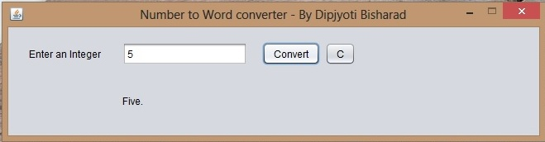

- Converting double digit number to words

a.
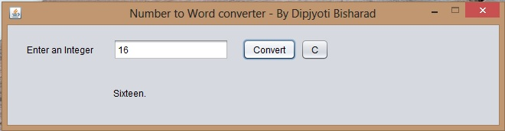

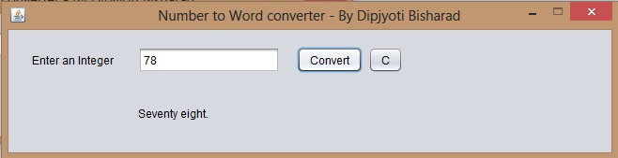
b.

3) Coverting a 5 digit number to words
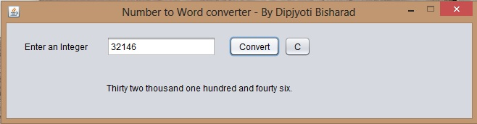

- Coverting a 9 digit number to words
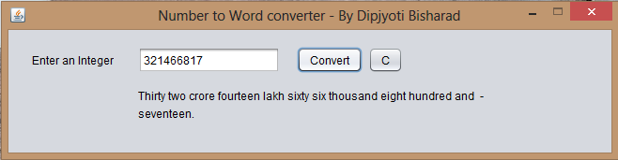

- Coverting a 19 digit number to words
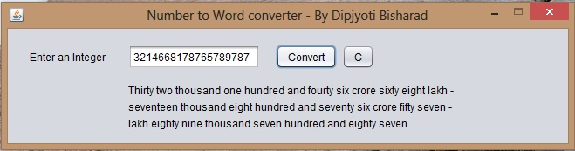

- Coverting a negative number to words
